**Assignment 3**

**Vishal Menariya**

**TR-1**

**Question 1: Basic Understanding of Users in Linux**

* **How many types of users exist in a Linux system? What is the UID range of it?**
* **Write a Linux command to check which users have access to the shell for executing commands.**

**Soln>**

Types of user:

1. Root user: Has full administrative access to the system.

UID – 0

1. System user: These are reserved for system processes and services.

UID – 1 to 999

1. Regular user: These are normal users created by the administrator or system users.

UID – 1000 and above

Linux Command to Check Users with Shell Access:

**cat /etc/passwd | grep -E '/bin/bash|/bin/sh' | cut -d: -f1**

**Question 2: An organization “Copex Pvt Ltd” has set up some users and groups for a project. Perform the following tasks step-by-step:**

**User and Group Creation:**

* **Create the following users and set a common password “pass” for all users: Nitesh, Mohan, Nitesh, Parul, Alex, Hitesh**
* **Create the following groups for this project: prod, test**

**Collaborative Directory Setup:**

* **As the root administrator, create a collaborative directory named “collaborative” under “/mnt”.**
* **Write a Linux command to change the owner & group-owner of the /mnt/collaborative directory to the “root & prod” group at a same time.**

**Answer the following questions:**

* **Write a Linux command to check the “default permissions, owner, and group owner” of the directory.**
* **Which users in this project fall under the "others" category for this directory?**

**Soln>**

**User Creation:**

**Collaborative Directory Setup:**

**Create a directory:**

mkdir /mnt/collaborative

**Change Owner & Group Owner Simultaneously:**

chown root:prod /mnt/collaborative

**Answer the following questions:**

**Linux command to check the “default permissions, owner, and group owner” of the directory:**

ls -ld /mnt/collaborative

**users project fall under the "others" category for this directory:**

Nitesh Mohan Parul Alex Hitesh

useradd Nitesh

useradd Mohan

useradd Parul

useradd Alex

useradd Hitesh

echo "pass" | passwd --stdin Nitesh

echo "pass" | passwd --stdin Mohan

echo "pass" | passwd --stdin Parul

echo "pass" | passwd --stdin Alex

echo "pass" | passwd --stdin Hitesh

**Group Creation:**

groupadd prod

groupadd test

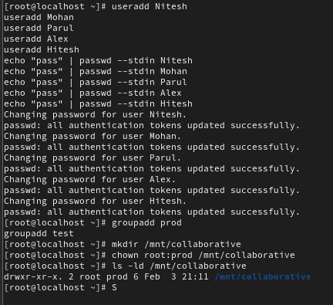

Question 3: Advanced Permission Management.

**Group Membership Assignment:**

1. As the root administrator, add users Mohan and Nitesh to the prod group as secondary group members

SOln>

Command to add users to prod group as secondary members:

**usermod -aG prod Mohan**

**usermod -aG prod Nitesh**

Verifying user addition:

**groups Mohan**

**groups Nitesh**

**Write the Linux commands to Apply the appropriate permissions as the root administrator and concepts to achieve this.**

1. Grant the prod group members permission to create and modify content in the /mnt/collaborative directory.

* **chmod 770 /mnt/collaborative**

Here,

7 – root (owner) – read(4), write(2), execute(1)

7 – prod (group) - read(4), write(2), execute(1)

0 – No permission

1. Restrict "others" from having no permissions in the /mnt/collaborative directory using the symbolic method.

* **chmod o-rwx /mnt/collaborative**
* **o- => remove from others**

**r-read, w-write, x-execute**

1. Create some files and directories in /mnt/collaborative and ensure that any new content created in /mnt/collaborative automatically inherits the same group ownership as the parent directory.

* **chmod g+s /mnt/collaborative**

**g+s -> adds groups special permission SGID**

1. Additionally, ensure that no one can delete the files created by others, except the file's creator.

* **chmod +t /mnt/collaborative**

Now, only **the file owner (creator) or root** can delete their own files.

**Verification Tasks:**

Log in as the user “Mohan” and:

1. Verify that user “Mohan” can create content in the “/mnt/collaborative” directory or not.

* **su – Mohan**

**touch /mnt/collaborative/testfile_Mohan.txt**

**ls -l /mnt/collaborative**

1. Now again what are the permissions for “Owner, Group & Other for ”/mnt/collaborative”, Describe the permission section of especially group & others.

* **ls -ld /mnt/collaborative**

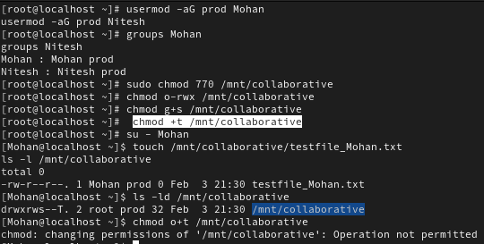

**Question 4: Write a command to remove the SUID special permission from the file /usr/bin/passwd using the numerical method & explain the impact of this change**

Soln>

Command Using the Numerical Method:

**chmod 755 /usr/bin/passwd**

**Impact**

The **SUID** bit allows **regular users** to run /usr/bin/passwd as root to change their own passwords.

**After removing SUID (chmod 755)**:

* Regular users **CANNOT** change their passwords anymore.
* Only **root** can modify user passwords.



Question 5: Set the UMASK Value:

* Write the Linux command to check the current “umask” value for the user's shell.
* How would you change the “umask” setting so that all newly created users on the system have a default “umask” value of `0777`?

Soln>

Checking the Current umask Value for the User's Shell:

**umask**

change the “umask” setting so that all newly created users on the system have a default “umask” value of `0777`:

**sudo nano /etc/profile**

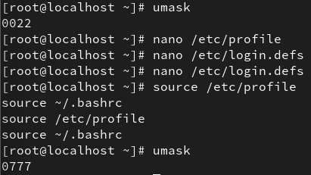**umask 0777**

Modify /etc/bash.bashrc:

**sudo nano /etc/bash.bashrc**

**umask 0777**

Modify /etc/login.defs (For Newly Created Users):

**sudo nano /etc/login.defs**

**UMASK 0777**

Applying the Changes:

**source /etc/profile**

**source ~/.bashrc**

verify: **umask**

**Question 6: Set the default permissions for the user Parul on newly created files and directories as follows:**

* **Set the default permissions for all newly created files to r--r--r--.**
* **Set the default permissions for all newly created directories to r-xr-xr-x..**

**Soln>**

Calculating umask:

Default file permission: 666 Default directory permissions: 777

Desired file permission: 444(rrr) Desired file permission: 555(rxrxrx)

umask = 666-444 -> 222 umask = 777-555 -> 222

**set Parul user umask – 0222**

**sudo nano /home/Parul/.bashrc**

add this line at end: **umask 0222**

apply changes: **source /home/Parul/.bashrc**

verify setting:

**touch testfile**

**ls -l testfile**

Create a test directory:

**mkdir testdir**

**ls -ld testdir**

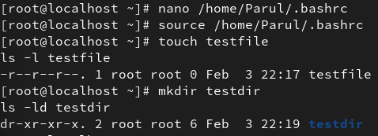

**Question 7: As a system administrator, configure the system to ensure that only the user Nitesh and the root user can modify the /etc/chrony.conf file, while all other users should have read-only access to it. Write the commands.**

**Soln>**

Change the File Ownership:

**chown Nitesh:root /etc/chrony.conf**

Set the Correct Permissions:

**chmod 644 /etc/chrony.conf**

**644(rw-r--r--)**

Verify:

**ls -l /etc/chrony.conf**

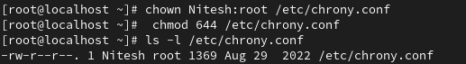

**Question 8: User Alex needs to be granted administrative privileges equivalent to the root user to manage the system, while ensuring that all other users retain their restricted access based on their roles. Describe how you would implement this configuration. Write the commands.**

**Soln>**

Add Alex to the wheel group:

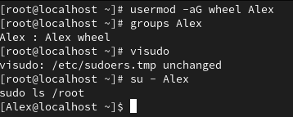**usermod -aG wheel Alex**

Verify groups of alex:

**groups Alex**

**visudo**

uncomment the line: **%wheel ALL=(ALL) ALL**

**su - Alex**

**sudo ls /root**

**Question 9: User Hitesh, a senior team member, requires full access to the system for daily operations. However, to prevent accidental shutdowns or reboots, configure the system so that Hitesh can execute all commands except poweroff and reboot. Write the commands.**

**Soln>**

Edit sudoers file:

**visudo**

Define a Custom Command Alias for Restricted Commands:

**# Command Alias for restricted commands**

**Cmnd_Alias RESTRICTED = /sbin/poweroff, /sbin/reboot**

Deny poweroff and reboot for Hitesh:

**# Allow Hitesh to execute all commands except poweroff and reboot**

**Hitesh ALL=(ALL) ALL, !RESTRICTED**

Check;

su – Hitesh

sudo poweroff #not work

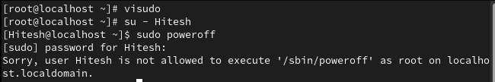

**Question 10: To safeguard all-important and critical system directories, ensure they cannot be deleted or removed by the root user. Write the commands you would use to implement this protection. *Hint: (/ is a top-level file system directory)**

**Soln>**

chattr +i /usr/bin /usr/sbin /root /boot /etc /var

